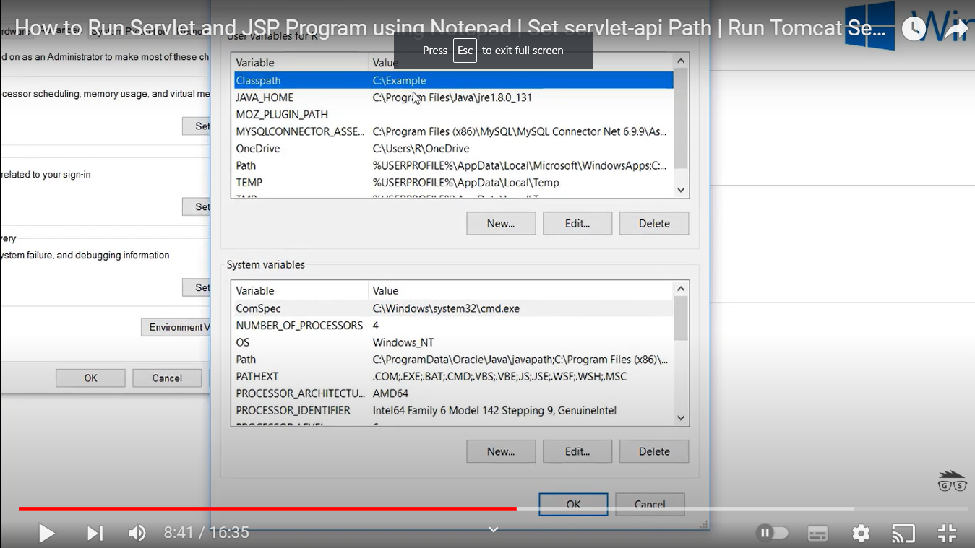

Env varable –

Classpath = D:\Java\apache-tomcat-9.0.87\lib\servlet-api.jar

JAVA_HOME = C:\Program Files\Java\jdk-18.0.1.1

